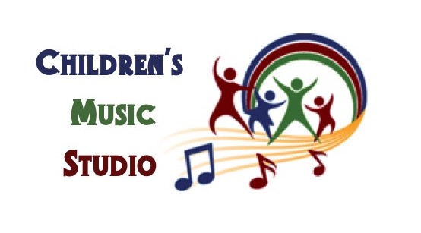

Welcome to Children’s Music Studio
Susan Caster/Danica Olson ~ Teachers

Give your child a world of possibilities.
From the moment they are born, you feel an overwhelming urge to give your children the world. Then life gets in the way. There are time and financial constraints, social pressures, and conflicting advice. How do you give your children the most beneficial experience within the constraints of modern life? Easy. You do it through music.
Studies from around the globe have shown that, from a very early age, music lessons can have profound long-term effects that include improved language development, higher standardized test scores in math, improved graduation rates, and even decreased likelihood of drug and alcohol use.
What Musikgarten offers is more than just an easy way to introduce your child to music. Our classes can play a critical role in your child’s social, emotional, intellectual, and physical development, as well as laying a pathway to musical proficiency. Moreover, Musikgarten provides dedicated time each week when you can bond with your child free from distractions and watch them grow into a confident, independent, and expressive young person.

Basic Information
Children’s Music Studio (CMS) is part of the Community Music Project (CMP), not for profit arts organization that has been in existence since 1978. CMP also oversees Chautauqua Chamber Singers, Jamestown Choral Society, and the CMP Chorale.

Contact Information
Joe Braeger
Susan Caster- Teacher cms@communitymusicproject.com

Danica Olson- Teacher
cms@communitymusicproject.com

Please find us on Facebook: Childrens Music Studio

CMP General Manager
715 Falconer St.
Jamestown NY 14701
jbraeger@communitymusicproject.com
Office phone 664-2227

Class Locations
Thursday night classes will be held at Warner Place located on Aldren Ave. on the Lutheran Campus, 715 Falconer St.. Friday morning classes will be held at 1st Presbyterian Church, 509 Prendergast Ave.. Jamestown. Enter through the door that faces 6th St. You will need to get ‘buzzed’

Tuition
The cost of the classes are listed on the website. The easiest and most dependable way to pay is through PAYPAL. You do not need to have a PAYPAL account to use this service, just a credit/debit card. If you choose to pay by check, make the check payable to CMP. Monthly payments ($35) are expected at the beginning of the month for the classes that month. Checks can be given to the teacher via an envelope system to record your payment. There may be a service fee for late and/or check issues.

Discounts
There are discounts for siblings. You will receive $35.00 off the $135.00 cost of the class for the second child in a family and the third child is FREE. Sibling whose age is outside the range for the class may attend free if they participate and are not disruptive to the class. Family Music classes are designed for the entire family for one fee.

If you recommend a new family that enrolls in CMS, we will offer you an additional $35.00 off the tuition cost that will be applied to your next semester.

Expectations
If you feel your child has an illness, please use your discretion as to your attendance in class.

It is perfectly fine for a child to wander during class activities. If the childs behavior becomes a distraction, it is the parent’s responsibility to correct the behavior.

The reinforcement of class concepts can he enhanced with the materials at home. Play the CD as much as you wish as well as doing the other activities covered in class. Musical bonding not only takes place in class but also at home..ENJOY!

Danica Olson

Susan Caster
We hope you offer the gift of music to a child!

